Fowlmere Village Hall 21st – 23rd March

THRIPLOW DAFFODIL EVENT Rally No 2

Grass pitches Post Code SG8 7RY
Directions A505 from Royston to B1368. Turn left signpost Fowlmere,
Turn right at start of village and left at the end of the houses

Rally Officers Michele & Mick Gilbert
E-mail:- michelegilbert74@hotmail.com
Mob: 07415 983178

A. R. Officers Viv & Mick Lucas Mob: 07891 596551

Attractions Daffodils galore in the lovely village of Thriplow. Lots to see and do including Craft fayre, motor show & lots more. There is live music all around the village and other rural entertainment, including Morris dancers.
Show opens Saturday and Sunday.
Event closes Sunday 3pm prompt.

Rally Opens Friday Noon Rally Limit 35 Rally Fee £40.00
Event Booking Form Available

What3Words /// sulk.fatherly.fordwarded

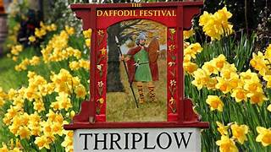

7

