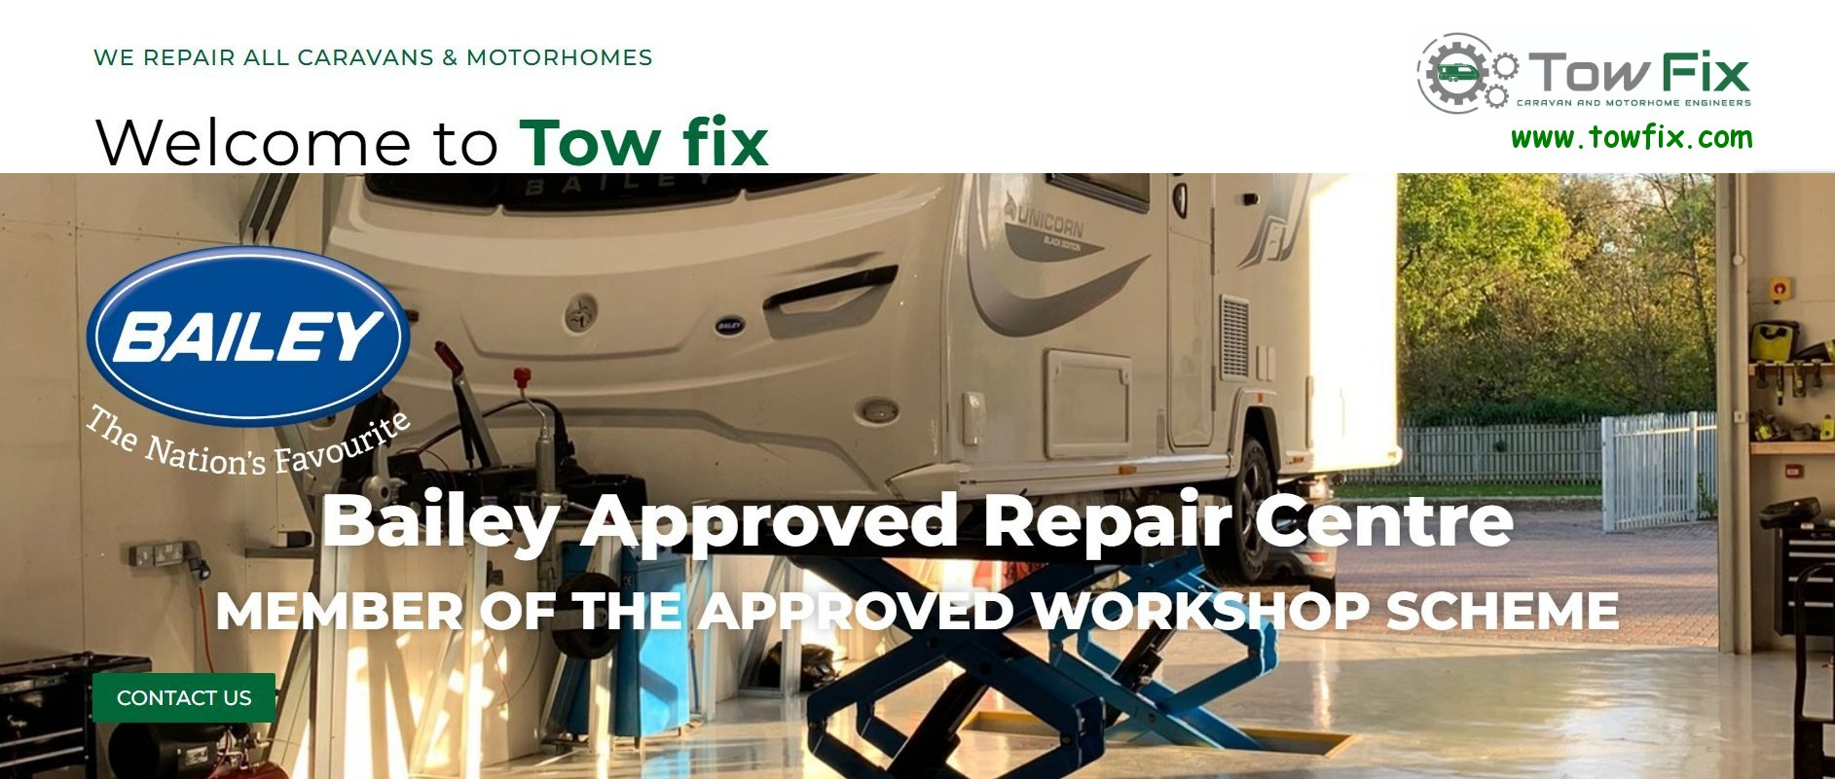

Welcome to Towfix. We are a fully qualified caravan and motorhome service
workshop. Based at Kingfisher Park, Arlesey Road, Henlow, Beds. SG16 16DD
If you are looking for a reliable and trustworthy caravan and motorhome service engineer then we are here to help. 01462 342054
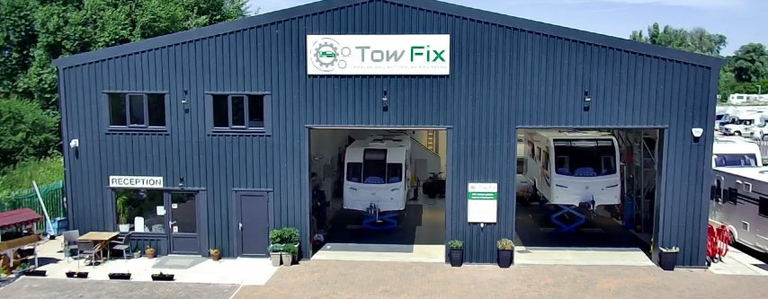
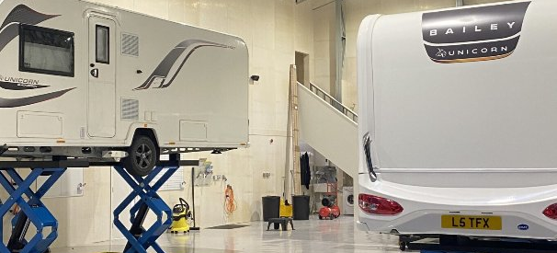
Towfix is a Bailey Approved Workshop Centre. We can submit your warranty claim and carry out warranty work on Bailey Caravans, Motorhome and Camper vans.

